CLOUD - DATA - GENAI LEARNING PATH

Day 8 - Configure CI Workflow
Detailed Lab Guide with GitHub Actions, GHCR, Azure App Service, Environments and QA Release Gates
Business scenario: Cencora-style training scenario: build and deploy a small Pharmaceutical Order API. It is sample training content only and does not represent any real Cencora internal system or data.

Batch model: Designed for 14 students using a shared Azure subscription and individual/team resource groups. Students should use their assigned GitHub repository and Azure App Service names.

1. Day 8 TOC Coverage
- Introduction Security on GitHub (Lab)
- Create secrets and connections
- Deployment environments
- Create CI workflow on GitHub Actions
- Push Docker image to GitHub Container Registry
- Create Azure App Service
- Configure CD/Release workflow
- Configure release workflow to push Docker image to QA
- Create App Service to deploy release to QA
- Use variables in workflow steps
- Schedules, triggers, deployment conditions and gates
- Deploy to QA from release workflow
- Practical exercise: run fully automated workflow to development environment by creating YAML

2. End-to-End Day 8 Architecture
Developer
|
| git push / pull request
v
GitHub Repository
|
v
GitHub Actions Workflow
|
+--> Build and test application
+--> Docker build
+--> Push image to GHCR
+--> Deploy to DEV Azure App Service
+--> Wait for QA environment approval
+--> Deploy same immutable image tag to QA App Service
Image registry:
ghcr.io/<owner>/cencora-order-api:sha-<commit>
Azure targets:
app-cencora-s01-dev
app-cencora-s01-qa

3. Prerequisites
- GitHub account with repository access.
- Git installed locally or GitHub Codespaces/GitHub web editor.
- Docker installed locally if students build images locally; GitHub-hosted runner can build Docker even if local Docker is unavailable.
- Azure subscription and resource group assigned to the student/team.
- Permission to create Azure App Service and App Service Plan.
- Basic sample app source code from this guide.
- Trainer-approved GitHub organization/repository naming convention.
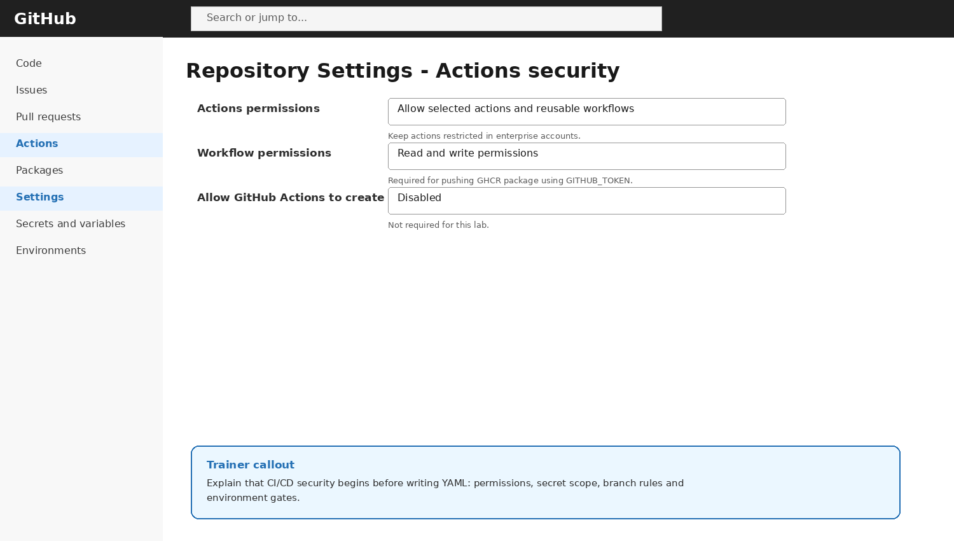
GitHub security settings
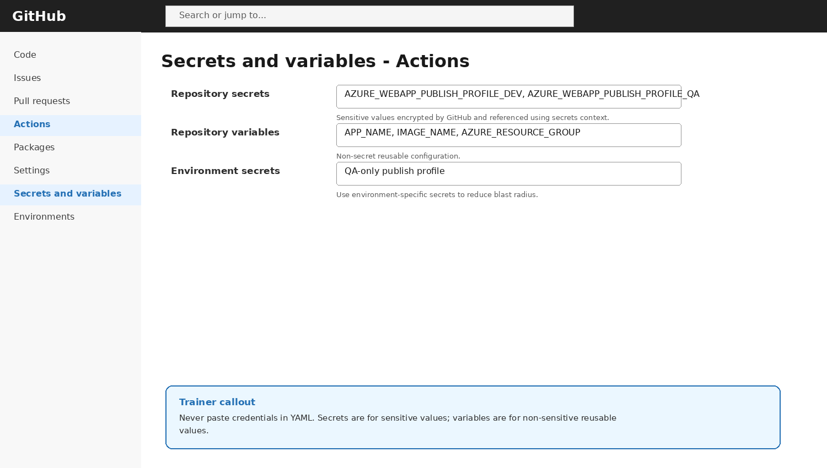
Secrets and variables
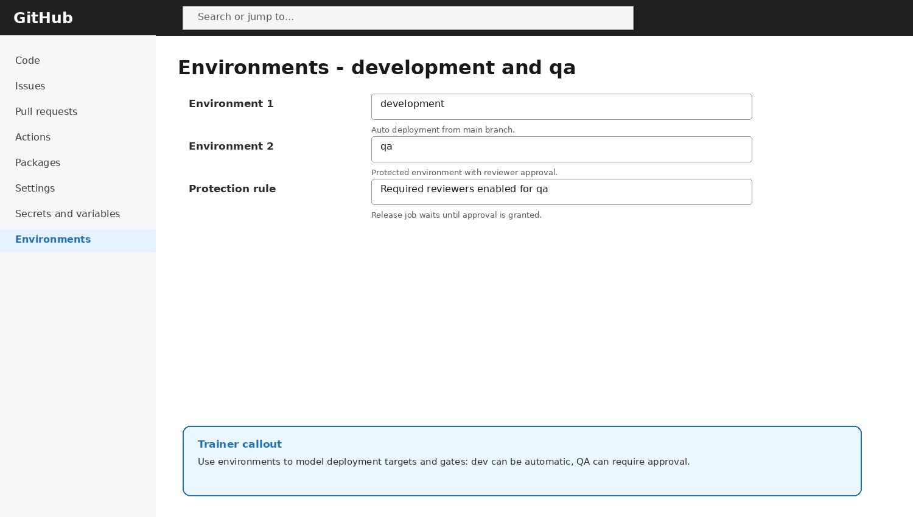
GitHub environments

4. Student Naming Convention
Item | Pattern | Student 01 example
GitHub repo | cencora-order-api-sNN | cencora-order-api-s01
Resource group | rg-cdg-sNN | rg-cdg-s01
App Service plan | asp-cencora-sNN | asp-cencora-s01
DEV web app | app-cencora-sNN-dev-<unique> | app-cencora-s01-dev-4827
QA web app | app-cencora-sNN-qa-<unique> | app-cencora-s01-qa-4827
Image name | ghcr.io/<owner>/cencora-order-api | ghcr.io/srinivasa/cencora-order-api

LAB 1 - Create GitHub Repository and Sample Application
Objective: Create a small Pharmaceutical Order API used throughout the CI/CD lab.
1. Create a new repository named cencora-order-api-sNN.
2. Add README.md with project purpose and team members.
3. Create folder app and file app/main.py.
4. Create requirements.txt, Dockerfile and .dockerignore.
5. Commit all files to main branch.
# app/main.py
from flask import Flask, jsonify, request
app = Flask(__name__)
@app.get('/health')
def health():
return jsonify({'status': 'UP', 'service': 'cencora-order-api'})
@app.post('/orders')
def create_order():
payload = request.get_json(silent=True) or {}
required = ['orderId', 'customerId', 'medicineCode', 'quantity']
missing = [x for x in required if x not in payload]
if missing:
return jsonify({'status': 'ERROR', 'missing': missing}), 400
return jsonify({'status': 'ACCEPTED', 'order': payload}), 202
if __name__ == '__main__':
app.run(host='0.0.0.0', port=8080)
# requirements.txt
flask==3.0.3
# Dockerfile
FROM python:3.12-slim
WORKDIR /app
COPY requirements.txt .
RUN pip install --no-cache-dir -r requirements.txt
COPY app ./app
EXPOSE 8080
CMD ["python", "app/main.py"]

LAB 2 - Configure GitHub Actions Security
Objective: Prepare the repository for safe workflow execution.
1. Open repository Settings -> Actions -> General.
2. Under Actions permissions, keep actions restricted according to organization policy.
3. Under Workflow permissions, select Read and write permissions only if required for GHCR package push using GITHUB_TOKEN.
4. Do not store secrets in workflow YAML or source code.
5. Create a branch protection rule for main if the account plan supports it.
UI reference - GitHub Actions security settings

LAB 3 - Create GitHub Environments
- Open repository Settings -> Environments.
- Create environment development.
- Create environment qa.
- For qa, enable Required reviewers if available.
- Set deployment branch rule to main only where supported.
- Explain that the QA deployment job will wait for approval.
UI reference - development and qa environments

LAB 4 - Create Azure App Services for DEV and QA
Objective: Create two Azure App Service targets that will receive container deployments.
1. Azure Portal -> App Services -> Create -> Web App.
2. Resource group: assigned resource group, e.g. rg-cdg-s01.
3. Name: app-cencora-s01-dev-<unique>.
4. Publish: Container.
5. Operating System: Linux.
6. Create/select App Service Plan: asp-cencora-s01.
7. Pricing tier: trainer-approved low-cost tier.
8. Repeat for QA: app-cencora-s01-qa-<unique>.
9. After creation, open each app Overview page and confirm the default domain exists.
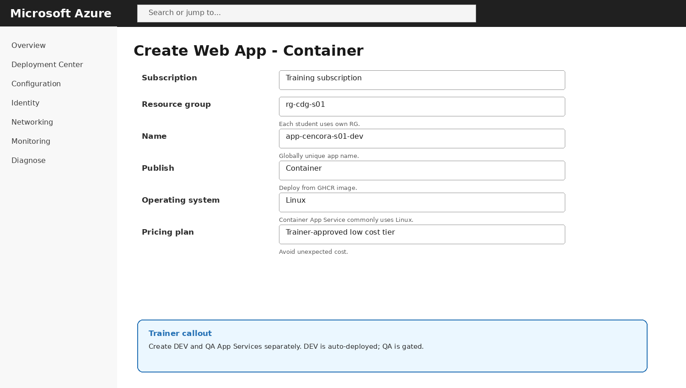
UI reference - Azure App Service container creation

LAB 5 - Create Secrets and Variables
Objective: Store sensitive deployment credentials as secrets and reusable non-sensitive configuration as variables.
1. Open Azure App Service DEV -> Overview -> Get publish profile.
2. Open GitHub repo -> Settings -> Secrets and variables -> Actions.
3. Create repository secret AZURE_WEBAPP_PUBLISH_PROFILE_DEV with DEV publish profile content.
4. Create repository secret AZURE_WEBAPP_PUBLISH_PROFILE_QA with QA publish profile content.
5. Create repository variables APP_NAME_DEV and APP_NAME_QA.
6. Create variable IMAGE_NAME with value ghcr.io/<owner>/cencora-order-api-sNN or equivalent.
7. Do not print secrets in logs.
UI reference - secrets and variables
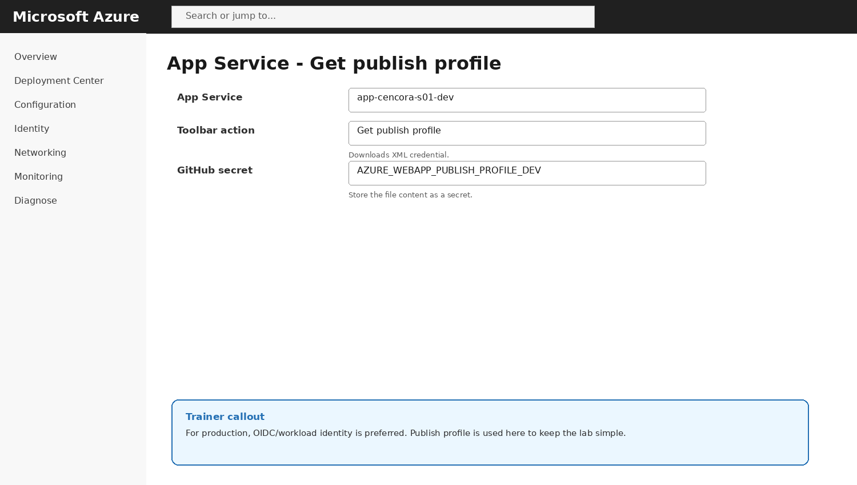
UI reference - Get publish profile from App Service

LAB 6 - Create Full CI/CD Workflow YAML
Create file .github/workflows/day8-ci-cd.yml. This workflow builds the app, pushes a Docker image to GHCR, deploys automatically to DEV, and deploys to QA after environment approval.
name: Day 8 CI CD to Azure App Service
on:
push:
branches: [ "main" ]
pull_request:
branches: [ "main" ]
workflow_dispatch:
inputs:
deploy_to_qa:
description: "Deploy to QA after build?"
required: true
default: "false"
schedule:
- cron: "30 3 * * 1-5"
permissions:
contents: read
packages: write
env:
REGISTRY: ghcr.io
IMAGE_NAME: ${{ github.repository }}
PYTHON_VERSION: "3.12"
jobs:
build:
name: Build and test
runs-on: ubuntu-latest
steps:
- name: Checkout source
uses: actions/checkout@v4
- name: Set up Python
uses: actions/setup-python@v5
with:
python-version: ${{ env.PYTHON_VERSION }}
- name: Install dependencies
run: |
python -m pip install --upgrade pip
pip install -r requirements.txt
- name: Smoke test application import
run: |
python -m py_compile app/main.py
docker_build_push:
name: Build and push image to GHCR
needs: build
if: github.event_name != 'pull_request'
runs-on: ubuntu-latest
outputs:
image_tag: ${{ steps.meta.outputs.image_tag }}
steps:
- name: Checkout source
uses: actions/checkout@v4
- name: Login to GHCR
uses: docker/login-action@v3
with:
registry: ${{ env.REGISTRY }}
username: ${{ github.actor }}
password: ${{ secrets.GITHUB_TOKEN }}
- name: Create image tag
id: meta
run: |
SHORT_SHA=$(echo "${GITHUB_SHA}" | cut -c1-7)
echo "image_tag=sha-${SHORT_SHA}" >> "$GITHUB_OUTPUT"
- name: Build Docker image
run: |
docker build -t ${{ env.REGISTRY }}/${{ env.IMAGE_NAME }}:${{ steps.meta.outputs.image_tag }} .
docker tag ${{ env.REGISTRY }}/${{ env.IMAGE_NAME }}:${{ steps.meta.outputs.image_tag }} \
${{ env.REGISTRY }}/${{ env.IMAGE_NAME }}:latest
- name: Push Docker image
run: |
docker push ${{ env.REGISTRY }}/${{ env.IMAGE_NAME }}:${{ steps.meta.outputs.image_tag }}
docker push ${{ env.REGISTRY }}/${{ env.IMAGE_NAME }}:latest
deploy_dev:
name: Deploy to DEV
needs: docker_build_push
runs-on: ubuntu-latest
environment: development
steps:
- name: Deploy container to Azure Web App - DEV
uses: azure/webapps-deploy@v3
with:
app-name: ${{ vars.APP_NAME_DEV }}
publish-profile: ${{ secrets.AZURE_WEBAPP_PUBLISH_PROFILE_DEV }}
images: ${{ env.REGISTRY }}/${{ env.IMAGE_NAME }}:${{ needs.docker_build_push.outputs.image_tag }}
deploy_qa:
name: Deploy to QA
needs: [docker_build_push, deploy_dev]
if: github.event_name == 'workflow_dispatch' && inputs.deploy_to_qa == 'true'
runs-on: ubuntu-latest
environment: qa
steps:
- name: Deploy same image to Azure Web App - QA
uses: azure/webapps-deploy@v3
with:
app-name: ${{ vars.APP_NAME_QA }}
publish-profile: ${{ secrets.AZURE_WEBAPP_PUBLISH_PROFILE_QA }}
images: ${{ env.REGISTRY }}/${{ env.IMAGE_NAME }}:${{ needs.docker_build_push.outputs.image_tag }}
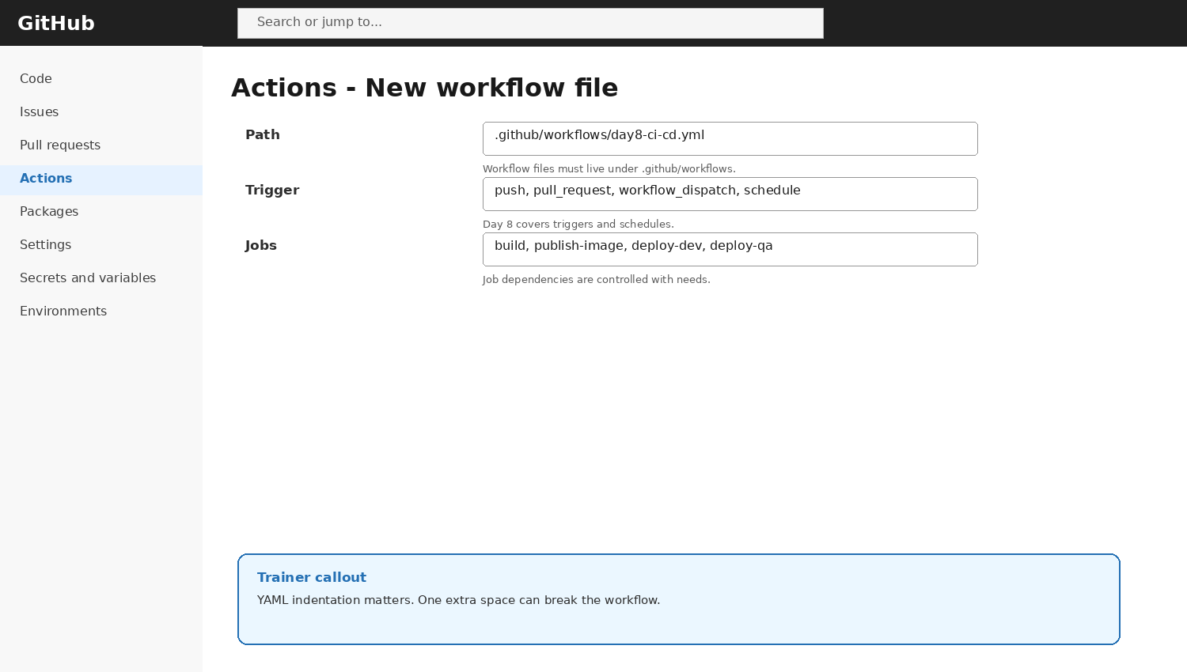
UI reference - create workflow YAML

LAB 7 - Validate CI Build and DEV Deployment
Objective: Run the workflow and verify DEV deployment.
1. Commit and push the workflow YAML to main.
2. Open GitHub Actions tab.
3. Open the workflow run.
4. Verify build job passes.
5. Verify docker_build_push job publishes the GHCR image.
6. Verify deploy_dev job succeeds.
7. Open DEV App Service URL and test /health.
8. POST a sample order to /orders using browser extension, curl or Postman.
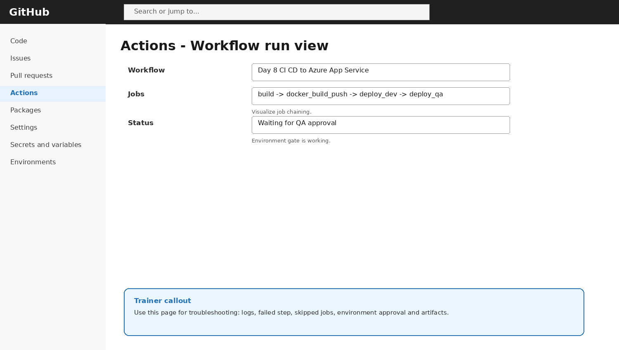
UI reference - workflow run visualization
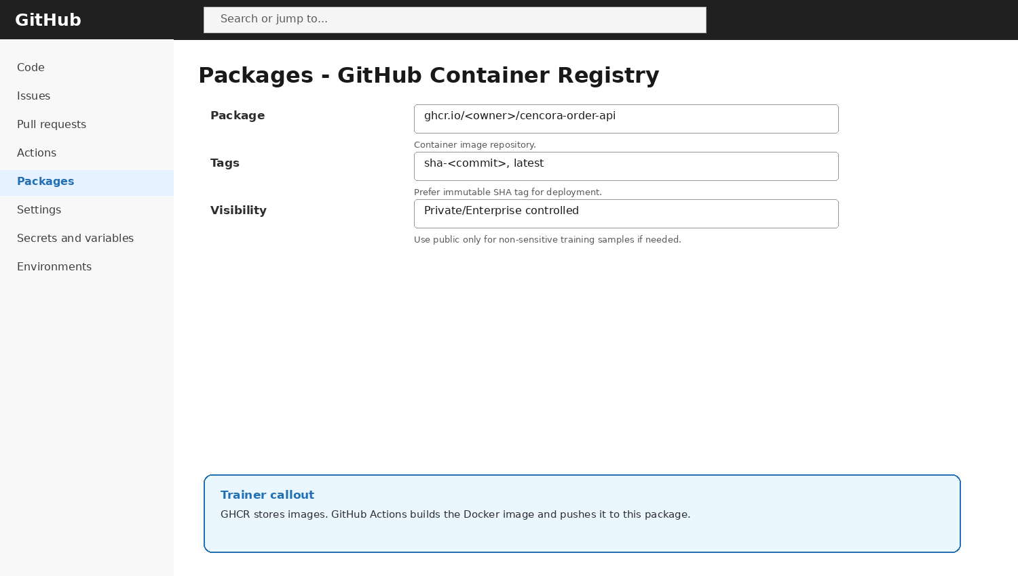
UI reference - GitHub Container Registry package
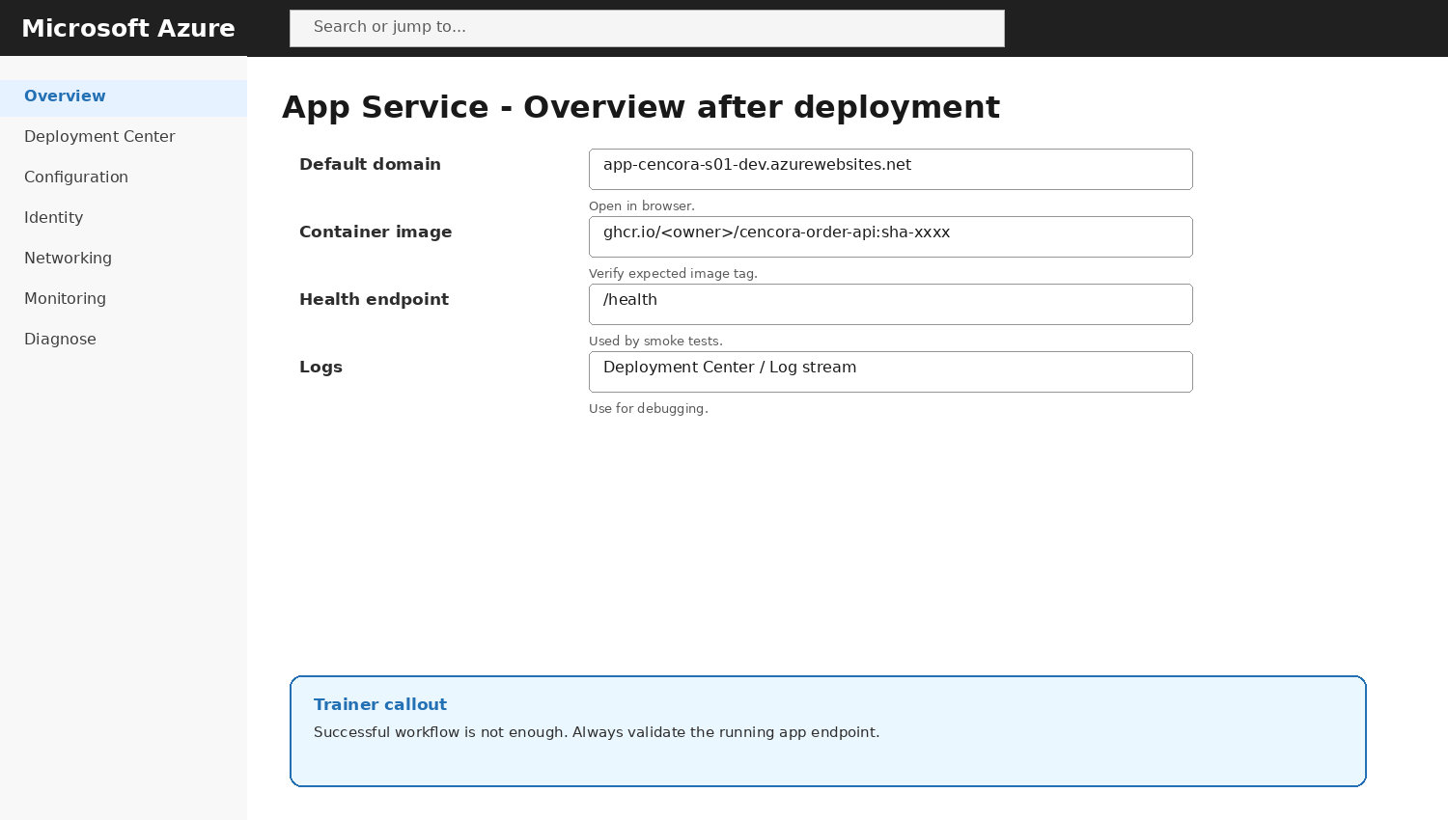
UI reference - deployed Azure App Service
curl https://<dev-app-name>.azurewebsites.net/health
curl -X POST https://<dev-app-name>.azurewebsites.net/orders -H "Content-Type: application/json" -d '{"orderId":"ORD-1001","customerId":"HOSP-101","medicineCode":"MED-5001","quantity":200}'

LAB 8 - Deploy to QA with Approval Gate
Objective: Run the manual release and approve the QA deployment.
1. Open GitHub Actions -> Day 8 CI CD to Azure App Service -> Run workflow.
2. Set deploy_to_qa = true.
3. Wait for build, image push and DEV deploy to complete.
4. Observe deploy_qa waiting for approval if QA environment has required reviewers.
5. Approve and deploy.
6. Open QA App Service URL and test /health.
7. Confirm QA received the same immutable sha-<commit> image tag.
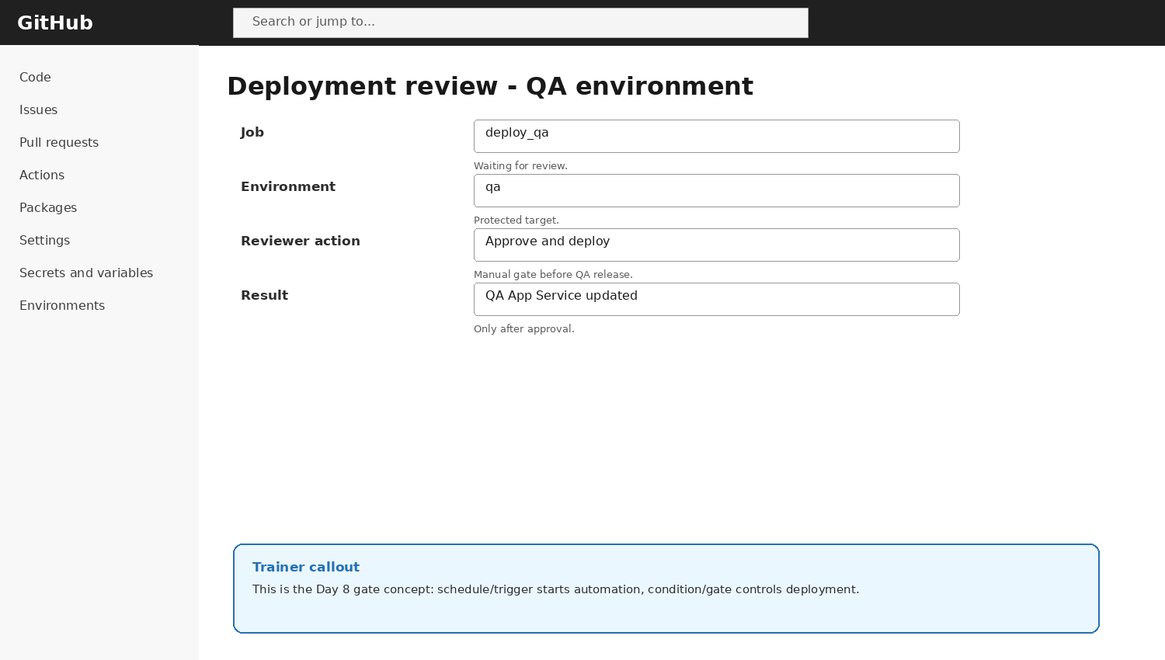
UI reference - QA deployment approval gate

LAB 9 - Variables, Conditions, Triggers and Schedule
Concept | YAML example | Trainer explanation
Variable | ${{ vars.APP_NAME_DEV }} | Non-secret configuration value stored outside YAML.
Secret | ${{ secrets.AZURE_WEBAPP_PUBLISH_PROFILE_DEV }} | Sensitive value encrypted by GitHub.
Condition | if: github.event_name != 'pull_request' | Prevents publishing images for PR validation.
Dependency | needs: build | Runs job only after build completes.
Environment | environment: qa | Connects job to QA target and approval rules.
Schedule | cron: "30 3 * * 1-5" | Runs on weekday schedule in UTC.
Manual trigger | workflow_dispatch | Allows trainer/student to run release manually.

10. Troubleshooting Matrix
Problem | Likely cause | Fix
Workflow does not start | YAML not in .github/workflows or trigger mismatch | Check path, branch and on section.
YAML syntax error | Indentation or colon issue | Use GitHub editor validation; check spaces.
GHCR push denied | packages: write missing or workflow permissions restricted | Check permissions block and repo Actions settings.
Deploy step fails | Wrong app name or publish profile secret | Recreate secret and verify vars.APP_NAME_DEV/QA.
App shows old version | Image tag not updated or app still pulling latest cache | Use immutable sha tag; restart app if required.
QA job skipped | workflow_dispatch input false or if condition not met | Run workflow manually with deploy_to_qa=true.
QA waits forever | Required reviewer not approving | Approve from deployment review screen.
App cannot pull private GHCR image | Registry credentials/visibility not configured | Use public sample image for lab or configure registry credentials properly.

11. GitHub Actions YAML Node-by-Node Explanation
Node | Meaning
name | Human-readable workflow name shown in the Actions tab.
on | Defines events that trigger the workflow.
push | Runs workflow when commits are pushed to matching branches.
pull_request | Validates code before merging.
workflow_dispatch | Manual button to run the workflow.
schedule | Cron-based run in UTC.
permissions | Limits what GITHUB_TOKEN can do.
env | Workflow-level environment variables.
jobs | Top-level collection of work units.
runs-on | Runner VM image used by the job.
steps | Ordered commands/actions inside a job.
uses | References a reusable GitHub Action.
run | Runs shell commands.
with | Inputs passed to an action.
needs | Creates job dependency chain.
if | Conditional execution.
outputs | Passes values from one job to another.
environment | Links job to GitHub environment and gates.
secrets | Sensitive values encrypted by GitHub.
vars | Non-sensitive reusable config values.

12. Student Deliverables
☐ GitHub repository URL.
☐ Screenshot of secrets/variables names only; do not expose values.
☐ Screenshot of development and QA environments.
☐ Workflow YAML file.
☐ Successful workflow run screenshot.
☐ GHCR package/image screenshot.
☐ DEV App Service URL and /health output.
☐ QA App Service URL and /health output.
☐ Short explanation of triggers, conditions, variables and gates.
☐ Troubleshooting note for one intentionally created issue.

13. Cleanup
- Delete DEV and QA App Services if not needed for Day 9.
- Delete unused App Service Plans.
- Delete temporary publish profiles and rotate/revoke credentials if necessary.
- Remove unnecessary package versions from GHCR if storage cleanup is required.
- Do not delete repository if it will be reused for Day 9.

